Motion and Force in a Gravitational Field

Home Assignment Circular Motion and Universal Gravitation
Name: _____________________________________________ (48 marks total)

- If a 1.50 kg ball is swung in a vertical circle at a constant speed of 2.40 ms⁻¹. Find the tension in the string at the bottom of the swing if the length of string is 1.20 m. (3 marks)

- While doing his Physics homework, Michael places a cup of milo (mass 0.659 kg) 10.0 cm from the centre of a microwave’s turntable and then turns the microwave on. Why waiting for the milo to heat, Michael notices that the microwave’s turntable spins at 5.0 revolutions per minute.
  - Find the tangential velocity on the cup. (3 marks)

  - Find the centripetal force on the cup. (2 marks)

- A railway line goes around a curve of radius 3.50 km. It is designed to carry a very fast train travelling at 360 kmh⁻¹ What would be the angle of banking for the tracks which would result in the best cornering? (3 marks)

- A car is driven around a circular track at a constant speed of 30.0 kmh⁻¹.
  - Is the car accelerating? _______________ (1 mark)
  - Explain your answer. (2 marks) ________________________________________________
__________________________________________________________________________________________________________________________________________________________________________________________________________________________________________________________________________________________________________________________________________________________________________________
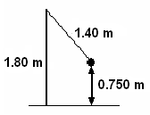
- In a game of totem tennis, a 1.20 kg ball is swung in a horizontal circle at a constant speed on a 1.80 m tall pole. The distance from the ball to the ground is 0.750 m and the length of the rope is 1.40 m. It takes 2.10 s for one revolution of the ball.

  - Draw a free body diagram of the situation and label the forces acting on the ball. (2 mark)

  - What is the ball’s acceleration? (3 marks)

  - What is the tension in the rope? (4 mark)

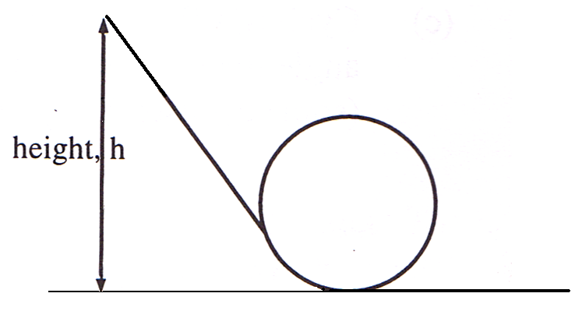
- In a spectacular stunt a motorcyclist, starting from rest, free wheels down a slope and into a loop. At what maximum height must the motorcycle be so that the motorcycle just completes one loop before continuing on. The diameter of the loop is 20.0 m. (4 marks)

- Sam is on a space-walk around his spaceship to repair a faulty antenna. If his spaceship is 250 km above the Earth, what is the gravitational field strength on him at this point? (3 marks)

- The International Space Station will be finished in 2011 and is expected to operate until at least 2015. It has a mass of 344 378 kg and completes 15.7 orbits every day. Its orbit is between 278 km and 460 km but on average about 370 km.
  - Calculate the period of the Space Station. Is it in geostationary orbit? Explain. (3 marks)

  - Calculate the speed of the Space Station and compare it to 27 743 kmh⁻¹ which is given by NASA. (4 marks)

  - Calculate the force of attraction between the Space Station and the Earth. (2 marks)

- A moon of Saturn moves in circular orbit of radius 1.00 x 10⁹ m and period of 1.00 x 10⁶ s. Calculate the mass of Saturn. (4 marks)

- Explain, using a mathematical proof, that all geostationary satellites are at the same altitude above the Earth regardless of their mass, then calculate the actual altitude. (5 marks)

